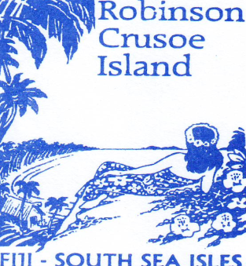
Robinson Crusoe Island,
Postal: P.O. Box 2580, Nadi
Phone: (679) 6280098 Fax: (679) 6282901
Email: robinsoncrusoe@connect.com.fj
Website: www.robinsoncrusoeislandfiji.com

WHOLESALE RATES FOR 2011 – 2012

Resort Contacts & Email Addresses

- Wayne Latter – Director wayne@robinsoncrusoeislandfiji.com
- Sanjay Prasad – Accountant accounts@robinsoncrusoeislandfiji.com
- Maureen Itautoka/Talica Toma – Reservation Consultant robinsoncrusoe@connect.com.fj
- Shobna Philitoga – Sales Representative travelshop@robinsoncrusoeislandfiji.com

Check in 11am
Check out 9am

Accommodation | Rack Rates
Island Lodge | 189.00
Bure Levu | 150.00
Island Bure | 150.00
Shell & Turtle Bure | 75.00
Tribal Dorm (28 beds) | 39.00pp
Aqua Dorm (18 beds) | 45.00pp

Compulsory Meal Plan to be purchased on the island: $65pp/per day
Return coach & boat transfer: $99pp
Child Policy: 0-4yrs FOC, 5-12yrs 50% off adult rate
Cancellation Policy – Notice received 7 days prior to arrival no charge, 7 days after arrival 1 nights accommodation booked will be charged. No show all accommodation will be charged.

Complimentary activities:

-all activities (snorkeling, kayaking, beach volleyball, coconut jewelry making, daily sunset & mid nite bonfire, daily happy hour at the bar, free admission to the pirates nite club, nite activities & many many more.
-free 15minutes beach massage
-Polynesian fire & knife show (6X a week)

Optional activities at extra cost:

-Fishing
-Diving
-Village Visit
-Tube Ride
-Non motorized water sports
-Upgrade massage

